**Phase 7: Integration & External Access (Beginner Steps)**

1. **Platform Events**
   * Setup → Platform Events → New.
   * Create Event Donation_Completed__e.
   * Add field: DonationId.
   * Publish event in Apex/Flow → Check in Event Monitoring.

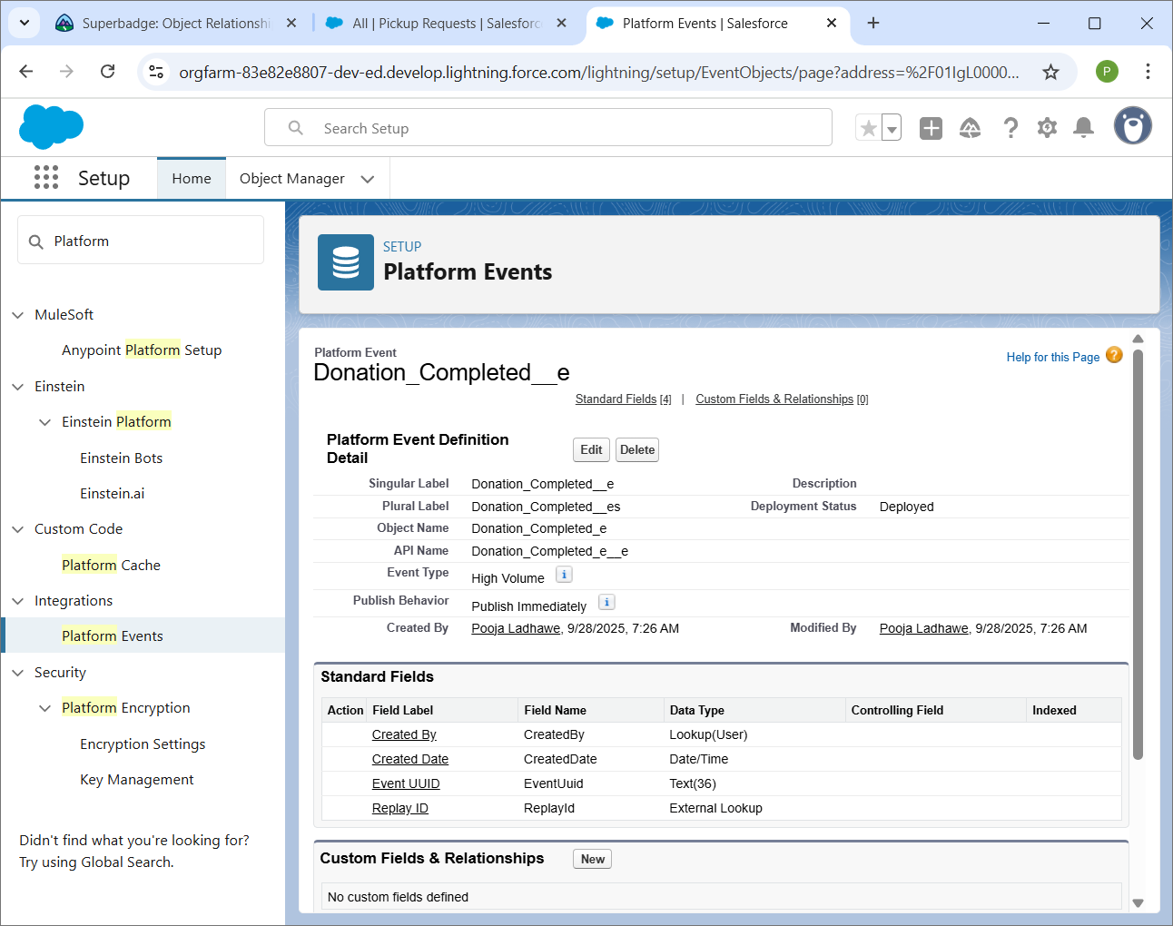

1. **Change Data Capture**
   * Setup → Change Data Capture → Enable for your object (e.g., Food_Donation__c).
   * Now Salesforce will stream record changes.

